My Health Log
Patient Name: _________________________
Weight:  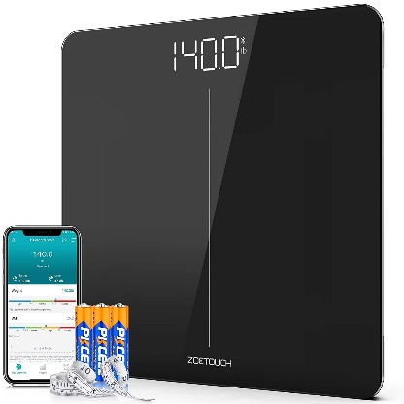 | Blood Pressure:  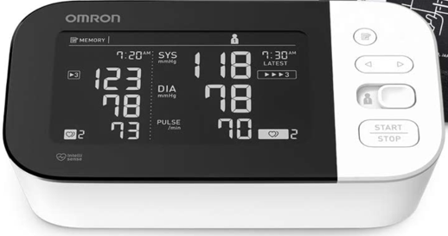 | Temperature:  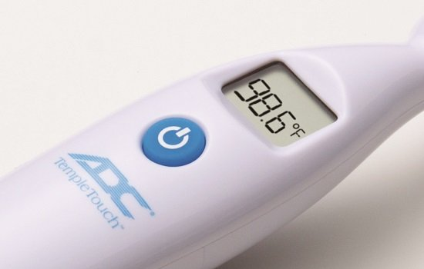

Date  (MM/DD/YY) | Time | Weight | Blood Pressure |  |  | Temperature | Notes
 |  |  | SYS  (Systolic) | DIA  (Diastolic) | Pulse  (Heart Rate)
Example  10/16/20 | 9:25am | 140.0 | 118 | 78 | 70 | 98.6 | Notes about how you were feeling, activities, etc.
My blood sugar (A1c) Log:
Patient Name: _________________________

My starting A1c | A1c level: | Date:
My A1c goal is:

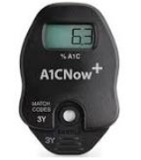
Test # | Date | Time | Reading
#1 | ___/____/___
#2 | ___/____/___
#3 | ___/____/___
#4 | ___/____/___

