Patient Name: _________________________ Date: ____________

- In general, how would you rate your overall health?

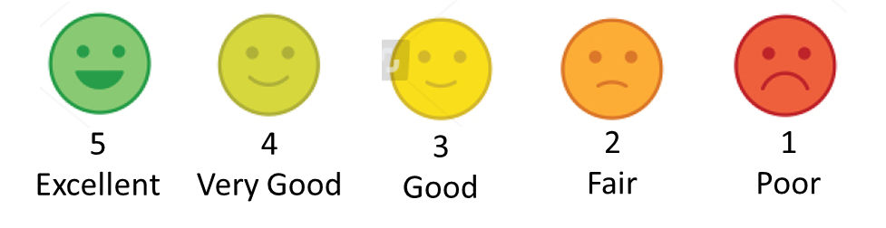

- How likely are you to recommend the health center to your family or friends?
☐ Always
☐ Often
☐ Sometimes
☐ Rarely
☐ Never

- How would you rate the care you receive at virtual visits with your provider as compared to in-person visits in the health center with your provider?
☐ Far Better
☐ Better
☐ Same
☐ Worse
☐ Much Worse

