EXAMPLE NEWSLETTER/EMAIL TO HEALTH CENTER LEADERS
re: Integrating Stress Regulation at Work
Email Subject Line:
Bring 5-minute stress management practices into your day-to-day work

We are working to build a workplace where employees are encouraged to feel well – regulate, relate, reason, and set the workplace boundaries they need to sustain their humanity.
To that end, we are asking you to bring brief (3-5 minute) regulation practices into your team meetings, supervisions, and other spaces where you connect with colleagues.
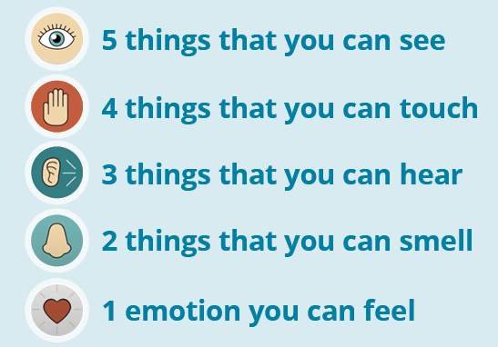
Each person and team may benefit from different practices to regulate when their cup is overflowing. We invite you to bring what feels right to you as a leader and collaborate with your teams to create brief spaces for these healing exercises in the day-to-day work. You might start with 1:1 supervision or in a weekly team meeting. The details are yours to determine. In your support, here are some examples of brief regulation practices. You may also find additional resources in the “Facilitator’s Guide to Micro-Resilience at Work.”
Optional regulation practice examples:
- 5-4-3-2-1 Mindful Moment or “Moment to Pause Script” (see page 6.)
- Sound and Visual Meditation: Forest Sounds or Underwater Images.
- Team Connection: Start with a prompt, i.e.,: What is the best human interaction you had this week? What one word describes the state of your being right now? What do you need to take care of yourself this week and can anyone in this room help?
- Acknowledgement and Shout Outs: Start meeting with sharing gratitude and shout outs for team members.
- Humor: Animals Swimming or Being Silly.
- Movement: 10 jumping jacks, head, shoulders, knees, and toes round or other stretching; ball toss challenge (catch 20 in a row.)

Again, these are just examples to inspire your own creativity and sense of what your team might enjoy. We know that many of you already are engaging in these practices and encourage you to continue.
If you have thoughts, questions, concerns, we want to hear from you. You can reach (insert contact information here

