EXAMPLE NEWSLETTER/EMAIL TO HEALTH CENTER STAFF
re: Integrating Stress Regulation at Work
Email Subject Line: Stop and take 5 minutes for You

We know the work never ends, but we are asking you to STOP for five minutes to check in and engage in a practice that releases stress.
To that end, here are a few brief regulation practices that are proven to support rest and recovery of an overtaxed nervous system. Can you find 5 minutes today to do one of them? When you’ve done it, please email (insert name of person such as Human Resource Director, CEO, Medical Director). The first 15 workers to complete the practice will get 2 extra hours of PTO this month.
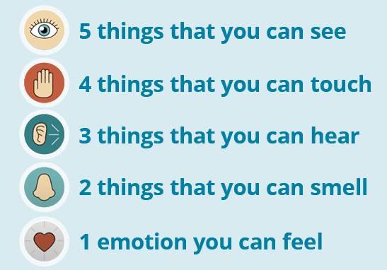
Optional regulation practice examples:
- 5-4-3-2-1 Mindful Moment or “Moment to Pause Script” (see page 6)
- Sound and Visual Meditation: Forest Sounds or Underwater Images.
- Humor: Animals Swimming or Being Silly.
- Movement: 10 jumping jacks; 1 round of head, shoulders, knees and toes or other stretching; ball toss challenge (catch 20 in a row.)
- Gratitude Journal: Write down 3 things from the past week that you are grateful for and take 3 minutes to visualize and re-experience one of them.
- Self-Care Assessment: Review the self-care assessment (see page 12). Decide on one action you want to take and ask a colleague or manager to help clear your schedule and hold you accountable to following through.

Again, the first 15 workers to complete this 5-minute challenge will get 2 hours of PTO. Just email us at (insert contact information here).
If you have thoughts, questions, concerns, we want to hear from you. You can reach (insert contact information here).

