Stress Management Worksheet
Mantra to guide me in this work ___________________________________________________
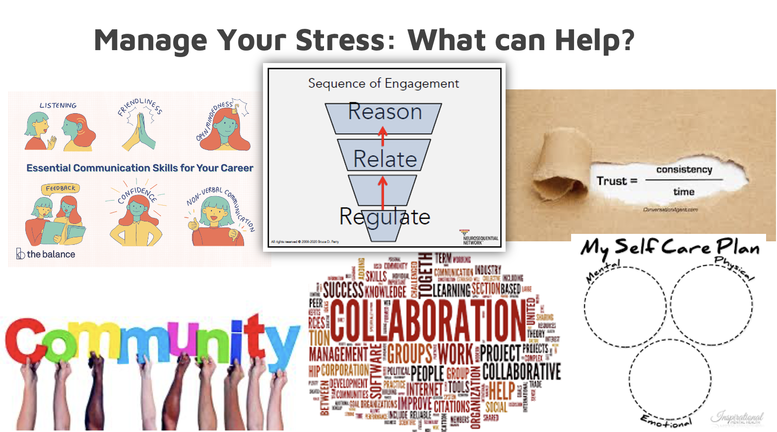

1) Regulation practices I will engage in daily, weekly, monthly, quarterly, annually.

2) Regulation practices I will do with my colleagues.

3) Regulation practices that I will bring to team meetings, to supervision, etc.

4) Who will support me to do this work inside the office?

Outside of the office?

Who do I need to ask to check in on me? When?

5) If I hit barriers to accomplishing these stress management goals, I will contact
(i.e., my supervisor/therapist/friend/mentor/etc.)

6) A vision of myself in 6 months from now if I am able to follow through on these intentions.
(i.e., I see myself doing a down dog; I see myself smiling and hiking in nature, I see myself playing with my kids, I see myself laughing with a friend, etc.)

