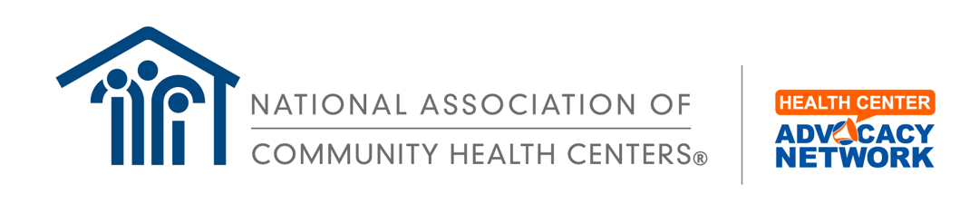

Sample In-District Meeting Scheduling Request
Subject Line: District Meeting Request - [Name of CHC] - Proposed Date XX/YY/ZZZZ
The Honorable [First Name] [Last Name]
U.S. House of Representatives / U.S. Senate
Washington, DC [20515 for House, 20510 for Senate]

Dear Representative/Senator [Last Name]:
[Name of CHC] is pleased to invite you to visit our Community Health Center (CHC) during the upcoming in-district period.
[Our health center] serves [X number] patients by providing comprehensive primary care services. The evidence shows that expanded access to primary care reduces healthcare costs by improving health outcomes and lowering rates of emergency department visits and unnecessary hospitalizations. More than half of our board comprises patients from the health center itself, making us uniquely responsive to our community’s primary care needs.
During a visit to our CHC, you will see firsthand the dedication of our physicians, dentists, nurses, pharmacists, and other staff to providing high-quality care to their patients. Our CHC also creates jobs in the community by employing [Y number] full-time employees. We offer career opportunities and pathways for advancement so that all our employees can see themselves in a rewarding career in primary care.
We are grateful for the long-standing bipartisan support for our mission. During your visit, we would like to discuss [the need for long-term, sustainable funding] so that we can continue to meet the demand for affordable primary and emphasize the importance of [protecting access to Medicaid]. These issues are critical to protecting our patients’ access to cost-effective primary care.
We hope witnessing Community Health Centers’ impact on your constituents’ lives and communities will provide valuable insight into your important work on Capitol Hill. Please reach out to [CONTACT] to schedule a visit. We look forward to welcoming you soon!
[Community Health Center Name] is located at:
Address ________________
City, State, ZIP ___________

Sincerely,
[Your Name]
[Your Title]
[Community Health Center Name]
[Community Health Center Website]

